**Query Logfile**

**Query 1:**

|  |  |  |  |  |  |
| --- | --- | --- | --- | --- | --- |
| 3 | 222 | 13:56:49 | select c.Customer_ID as Customer_ID, concat(c.customer_lname, ',', c.customer_fname) as name, c.Customer_Gender as gender, a.Account_Balance as balance, a.Account_Opened as Account_Opened, a.Account_Last_Accessed_Date as Last_Accessed_Date from Customer as c left join Accounts as a on(c.Customer_ID = a.Customer_ID) where Account_Balance > 250000 and c.Customer_Gender = 'F' LIMIT 0, 1000 | 4 row(s) returned | 0.000 sec / 0.000 sec |

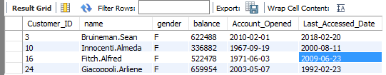

**Query 2:**

|  |  |  |  |  |  |
| --- | --- | --- | --- | --- | --- |
| 3 | 229 | 14:36:46 | select a.ATM_City as city, concat('$',SUM(a.ATM_Balance)) as balance, a.ATM_Brand as brand from ATM as a where a.ATM_City = 'New Orleans' and a.ATM_Brand = 'Ameritech' order by a.ATM_Brand LIMIT 0, 1000 | 1 row(s) returned | 0.000 sec / 0.000 sec |



**Query 3:**

|  |  |  |  |  |  |
| --- | --- | --- | --- | --- | --- |
| 3 | 230 | 14:38:41 | select count(e.Emp_ID) from Branch as b left join Employee as e on(b.Branch_ID = e.Branch_ID) where b.Branch_ID = '23' LIMIT 0, 1000 | 1 row(s) returned | 0.000 sec / 0.000 sec |

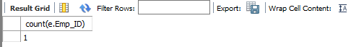

**Query 4:**

|  |  |  |  |  |  |
| --- | --- | --- | --- | --- | --- |
| 3 | 231 | 14:39:52 | select c.Customer_ID, concat(c.customer_fname, '', c.customer_lname) as name, c.Customer_Last_Maintained_Date as last_maintained, c.Customer_Upcoming_Maintenence as upcoming_maintenence from Customer as c where c.Customer_Last_Maintained_Date < '2010/1/1' LIMIT 0, 1000 | 17 row(s) returned | 0.000 sec / 0.000 sec |

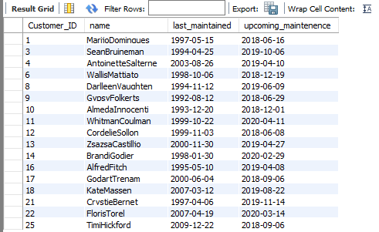

**Query 5:**

|  |  |  |  |  |  |
| --- | --- | --- | --- | --- | --- |
| 3 | 232 | 14:41:09 | select o.Customer_ID, o.Owns_Amount_On_Opening_Date, o.Owns_Type_Of_Account from owns as o where o.Owns_Type_Of_Account = 'Student' LIMIT 0, 1000 | 13 row(s) returned | 0.000 sec / 0.000 sec |

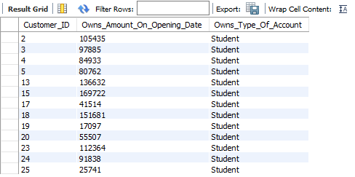

**Query 6:**

|  |  |  |  |  |  |
| --- | --- | --- | --- | --- | --- |
| 3 | 233 | 14:42:02 | select DISTINCT e.Emp_Title as title, AVG(e.Emp_Salary) as Salary from Employee as e LIMIT 0, 1000 | 1 row(s) returned | 0.000 sec / 0.000 sec |



**Query 7:**

|  |  |  |  |  |  |
| --- | --- | --- | --- | --- | --- |
| 3 | 234 | 14:45:20 | select a.ATM_ID, count(a.ATM_Cards_Collected) from ATM as a left join Branch as b on (a.Branch_ID=b.Branch_ID) LIMIT 0, 1000 | 1 row(s) returned | 0.000 sec / 0.000 sec |

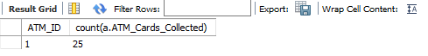

**Query 8:**

|  |  |  |  |  |  |
| --- | --- | --- | --- | --- | --- |
| 3 | 235 | 14:46:37 | select c.Customer_ID, concat(c.customer_lname, ',', c.customer_fname) as name, c.Customer_Birthdate as birthday from Customer as c where c.Customer_Birthdate > '1994-5-19' and c.Customer_Birthdate < '2018-1-1' LIMIT 0, 1000 | 8 row(s) returned | 0.000 sec / 0.000 sec |

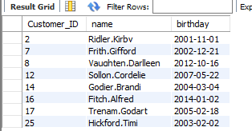

**Query 9:**

|  |  |  |  |  |  |
| --- | --- | --- | --- | --- | --- |
| 3 | 236 | 14:49:02 | select e.Emp_Compensation as Benefits, e.Emp_Fname as First_Name, e.Emp_Lname as Last_Name, b.Branch_ID as Branch_ID from Employee as e left join Branch as b on (b.Branch_ID = e.Branch_ID) WHERE e.Emp_Compensation = 'Health and Dental' LIMIT 0, 1000 | 8 row(s) returned | 0.000 sec / 0.000 sec |

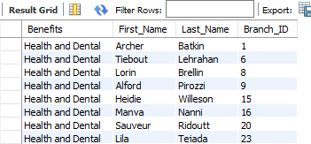

**Query 10:**

|  |  |  |  |  |  |
| --- | --- | --- | --- | --- | --- |
| 3 | 237 | 14:56:57 | select c.Customer_Birthdate, c.Customer_ID, c.Customer_Gender from Customer as c left join Employee ON Customer_ID = Emp_ID LIMIT 0, 1000 | 25 row(s) returned | 0.000 sec / 0.000 sec |

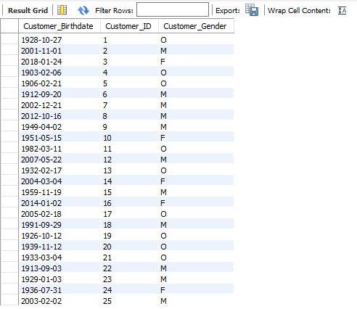

**Query 11:**

|  |  |  |  |  |  |
| --- | --- | --- | --- | --- | --- |
| 3 | 236 | 14:30:58 | select c.Customer_ID as ID, c.customer_fname as Customer_First, c.customer_lname as Customer_Last, c.Customer_Gender as Gender, c.Customer_City as City from Customer as c where c.customer_fname like 'k%' and c.customer_lname like 'm%' LIMIT 0, 1000 | 1 row(s) returned | 0.000 sec / 0.000 sec |

